|  |
| --- |
| Brandon Carnell |
| Advanced Web |
| **My Portfolio** |
| Version 1.0  All work Copyright © 2014 by Brandon Carnell.  All rights reserved. |
| **Brandon Carnell** |
|  |



|  |
| --- |
| January 30th, 2014 |

**Table of Contents**

Version History – Page 3

Navigation Bar information – Page 4

Colour swatches – Page 5

Typography – Page 6

Branding – Page 7

Wire Frames – Page 8

**Version History**

Version 0.1 – Initial Foundation Framework

Version 0.2 – FontAwesome icons and Navigation Bar created

Version 0.3 – Home.html partially created

Version 0.4 – Home.html finished. Copyright and images added

Version 1.0 – All other pages created. Internal documentation updated

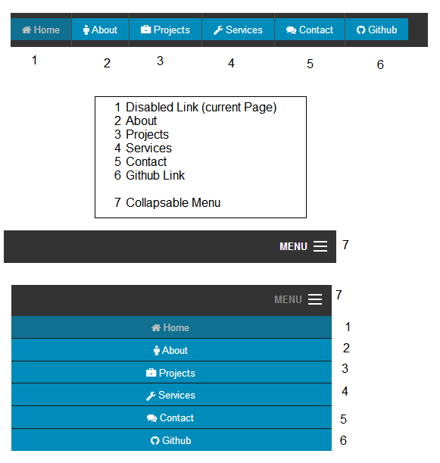

All colours taken from the Foundations package customizer

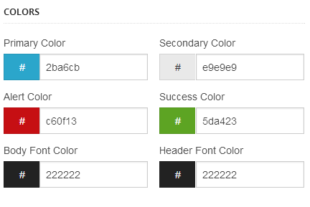

All fonts on the site are Helvetica or other sans serif of not applicable.

Icon created with Dimitri.tff

Icons created with the FontAwesome Webfont and are available at <http://fontawesome.io/>

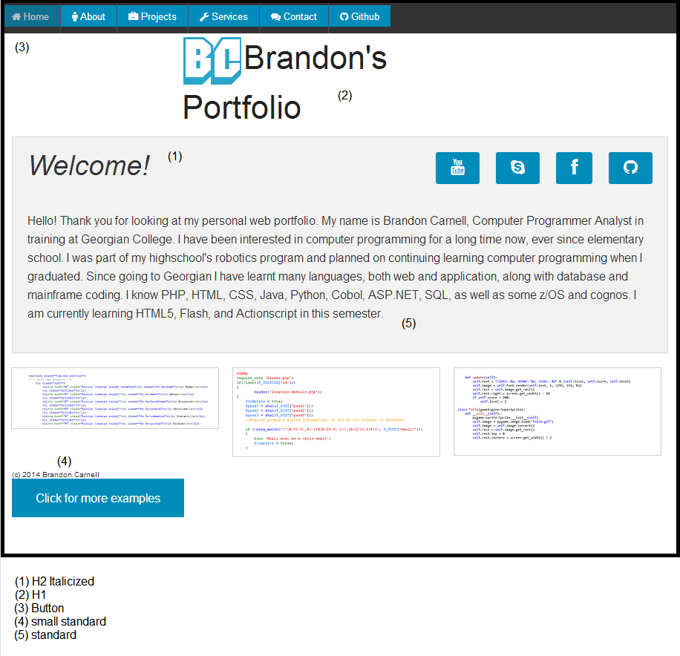

Logo created with Dimitri Swank, size 72 in Foundation Primary to match the rest of the site. #2ba6cb

